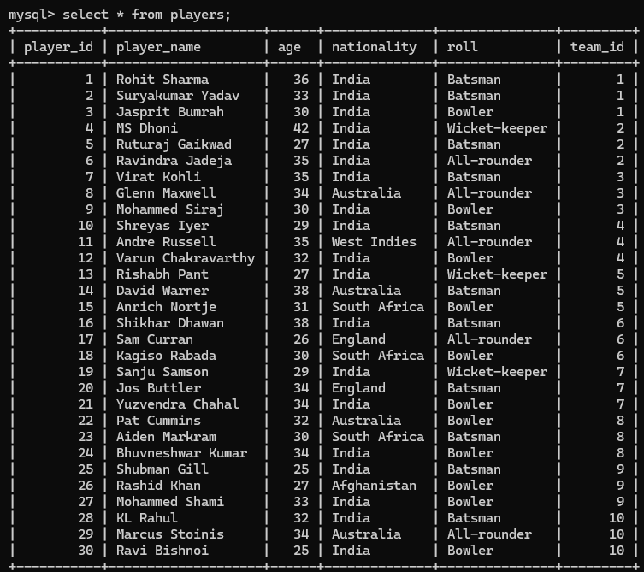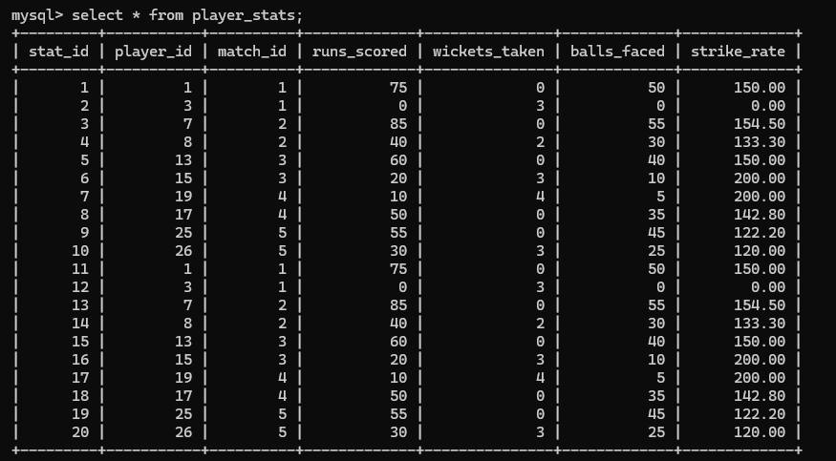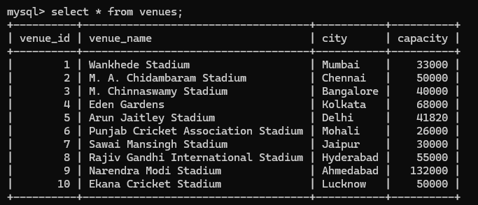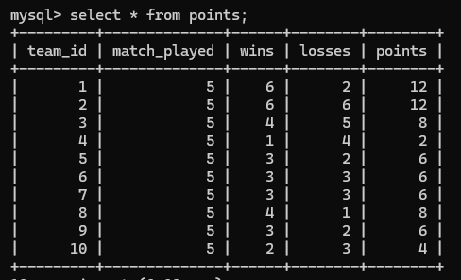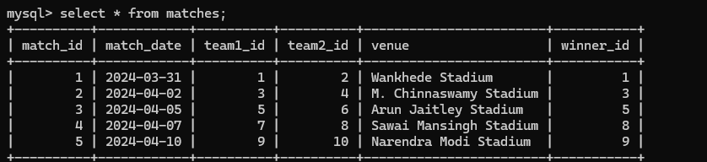

*Query1. Created table players and inserted data in it.*

*Query2. Created table player_stats, venues and inserted data in it.*

*Query3. Created table points, matches and inserted data in it.*